Dues & Forms: May, June, July – Scan the red QR code for the Dues Calendar
– Scan the blue QR code for Dues: What to Send Where
– Scan the green QR code for Forms: What to Send Where
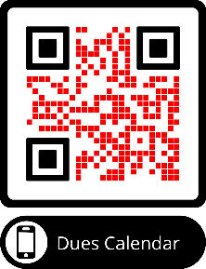 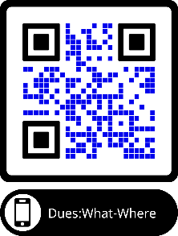 Forms: Send/Where

